The requirement to create a file store service, has been achieved using java APIs. The architecture diagram of the server , along with various design assumptions have been described in this document.

The code was developed on a Intellij IDE environment.

**Server side design**

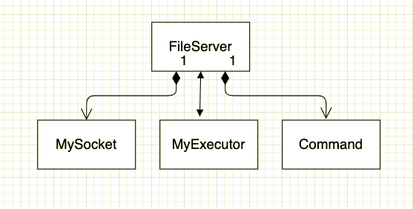

**Execution instructions**

* First , two shell script files freqWords.sh and wordcount.sh , must be placed in the FileServer folder as shown below, and executable permissions must be assigned to it
* 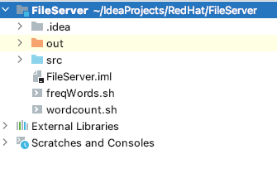

Run the server from cmd prompt of the folder where FileServer.class is located

**Assumptions made**

* Server listens only on localhost and port 1988
* Server is based on a multithreaded executor model
* Nbr of clients and nbr of files per client are less. This is the basis for choosing a concurrenthashmap to store list of files on the server
* Files are read in chunks of 1024 bytes
* Files are stored directly in the folder of FileServer